`

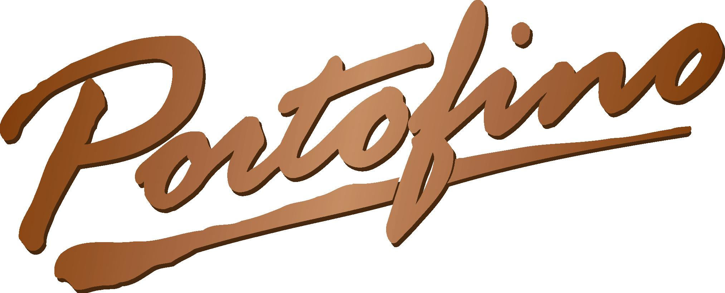

2016

Restaurant

and

Banquet Facility

3455 Biddle Avenue
Wyandotte, Mi 48192
Phone: 734-281-6700
Fax: 734-250-9359
Portofinoontheriver@wyan.org
www.portofinoontheriver.com
GPS 92 degrees11’52,14” by 83 degrees 8’57,92”

Banquet Manager
Marne Walker
Cruise Director
Robert Armstrong

About Us

Thank you for considering Portofino. Please use this as a guide to help you in planning the perfect event. We will be happy to assist you in all aspects of designing your custom event. From food, beverage and cakes, to flowers, decorating and entertainment, Portofino will help make your dreams match your financial budget. You need not travel to Italy to have the finest in Italian and Continental cuisine.

Portofino offers a variety of custom event planning options. Enjoy a moonlight river cruise aboard our cruise ship The “PORTOFINO FRIENDSHIP”. There is always something exciting to see as you cruise the Detroit River, one of the world’s busiest international waterways, with all its historical sights and scenery. The Friendship is U.S. Coast Guard certified, accommodates up to 100 passengers and has its own bar. The Friendship is perfect for holding an intimate evening reception or throwing an unforgettable party. Daytime cruises are also available.

Do you prefer to keep your feet on land? Our “RIVER ROOM” (all season deck) and “GLASS ROOM” offers spectacular river views year round. In the summer, watch as everything from small personal watercraft to huge freighters pass by. In the winter, the snow covered island trees and ice flows are beautifully captivating. Stun your guests with the most breathtaking views of any banquet center that Michigan can offer. Accommodates parties of 50 and up.

Our “AUGUSTE ROOM” is elegance on a small scale. This private dining room is perfect for small gatherings such as anniversary dinners, marriage proposals or simply a special evening out. The Auguste Room accommodates up to 18 people.

The “BANQUET ROOM” offers seating for up to 200 guests. Whether you would like to hold a beautiful reception for 200 or a seminar for 15, Portofino offers custom banquet packages for any need.

Also, you may consider a catered event to any location that you choose, formal or informal. You select the theme and menu and we provide everything else from chairs to service.

Executive Chef Jeffrey Mellas and Banquet Manager Marne Walker are available to assist you in customizing your dream event. The Chef’s Themed Dinners are a unique way to make any event extraordinary. From Caribbean dinners, to Barbeque picnics, to Wild Game dinners, Chef Mellas creates menus from ports across the world. Also available are our world-class wine dinners for groups from 20 to 60 people.

By choosing Portofino, you are guaranteeing yourself an event that will be memorable. With delicious and unique food, gorgeous atmosphere, and the ability to customize your own event, you cannot go wrong with Portofino. Thank you, and let us know of any way we may assist you.

How to Find Us

Portofino is located right on the Detroit River in the heart of downtown Wyandotte

Directions from Detroit

Take Interstate 75S to Eureka Rd (exit 36). Travel east on Eureka 5 miles to Biddle Ave. Turn right on Biddle Ave.; Portofino will be about .1 miles ahead on the left.

Directions from Plymouth, Northville, Livonia and surrounding areas

Take Interstate 275S to Eureka Rd (exit 15). Travel east on Eureka 11 miles to Biddle Ave. Turn right on Biddle Ave.; Portofino will be about .1 miles ahead on the left.

Directions from Pontiac, Royal Oak, Auburn Hills and surrounding areas

Take Interstate 75S to Eureka Rd (exit 36). Travel east on Eureka 5 miles to Biddle Ave. Turn right on Biddle Ave.; Portofino will be about .1 miles ahead on the left.

Directions from Port Huron, Mt. Clemens and surrounding areas

Take Interstate 94 W to Southfield Rd (exit 204). Travel east on Southfield 5 miles to W. Jefferson Ave. Follow Jefferson south 4 miles (Jefferson will become Biddle) past Eureka Rd. Portofino will be about .1 miles ahead on the left.

Directions from Lansing and Brighton Areas

Take Interstate 96 E to Interstate 275S interchange to Eureka Rd (exit 15). Travel east on Eureka 11 miles to Biddle Ave. Turn right on Biddle Ave.; Portofino will be about .1 miles ahead on the left.

Directions from Monroe Area

Take Interstate 75 N to Eureka Rd (exit 36). Travel east on Eureka 5 miles to Biddle Ave. Turn right on Biddle Ave.; Portofino will be about .1 miles ahead on the left.

Directions from Western Michigan

Take Interstate 94 E to Interstate 275S (exit 194) to Eureka Rd (exit 15). Travel east on Eureka 11 miles to Biddle Ave. Turn right on Biddle Ave.; Portofino will be about .1 miles

ahead on the left.

3455 Biddle Avenue
Wyandotte, Mi 48192
Phone: 734-281-6700
Fax: 734-281-0733
Portofinootheriver@wyan.org
www.portofinoontheriver.com
GPS 92 degrees11’52,14” by 83 degrees 8’57,92”

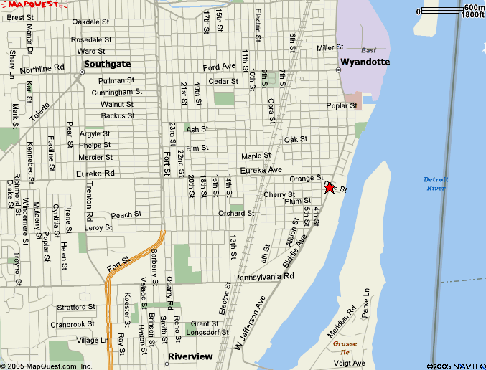

For more detailed maps, visit our web page at www.Portofinoontheriver.com, and click on the Map link
Hors D’oeuvres

Small Trays Serve 35-40 Large Trays Serve 75-80

Assorted Cheese and Cracker Tray Small $55.00 Large $80.00

Fresh Fruit Tray Small $55.00 Large $80.00

Assorted Fresh Vegetable and Herb Dip Small $55.00 Large $80.00

Hot Crab Dip Small $55.00 Large $80.00

Shrimp Cocktail or Peel and Eat Shrimp Per Pound Market Price

Boneless Buffalo Wings $30.00 per 50

Buffalo Wings $35.00 per 50

Chicken Wings $35.00 per 50

Mushroom Meatballs $30.00 per 50

Chicken Strips $50.00 per 50

Crab Stuffed Mushrooms $40.00 per 50

Coconut Chicken Strips $40.00 per 50

Coconut Shrimp $100.00 per 50

BBQ Riblets $75.00 per 50

Crab Cakes $3.00 Each

Antipasto Platters Serves 8-10 $20.00

Italian salami, pepperoni, imported mozzarella cheese, pepper cheese,

pepperoncini, olives, and fresh tomato wedges with fresh cracked pepper

Brunch and Luncheon Menu Times - must be served prior to 2 pm to maintain pricing
Pricing for all banquet events are priced per person plus 6% tax and 21% gratuity
Restaurant and catering events are paid directly following the event with one total payment for all guest
Credit cards and cash only are accepted for final payment. Checks will not be accepted
Cruises are paid in full prior to departure
Three weeks prior to your event you must:
#1 finalize your guest count- your payment is based on this number plus extra guest
#2 finalize your menu
#3 finalize your seating and table set-up -
Please be aware that seasonal items on our menu may change
There is a $100 fee associated with the use of confetti on Portofino property or the use of tape on walls or ceiling surfaces
All banquet deposits are non-refundable
Your guest check average per person before tax and gratuity must equal :
Between the hours of 8 am and 2pm $17
From 2 pm until 12 am $22
River Room minimum for Lunch 50 Guests, $850; Dinner 50 Guests $1100

Continental Breakfast $10
Serving time must be before 10 am

Assorted breakfast pastries, coffee and orange juice

Create Your Own

Brunch Menu starting at $15
Serving time must be before 1 pm

Eggs, bacon, sausage, french toast, fresh fruit and hash browns and bagels

Additional Selections

Priced per person per item

$2 per person per item

Pasta Salad

Chef’s Potato

Fresh Vegetables

Tossed Salad & Rolls

Mostaccioli
Breakfast Pastries

$3 per person per item

Peel and Eat Shrimp

Broiled Salmon

Roasted Chicken

Roasted Beef

Chicken Piccata

Roasted Turkey

Eggs Benedict

Chef’s Omelet Station $3 per person

Brunch and Luncheon Menu Times - must be served prior to 2 pm to maintain pricing
Pricing for all banquet events are priced per person plus 6% tax and 21% gratuity
Restaurant and catering events are paid directly following the event with one total payment for all guest
Credit cards and cash only are accepted for final payment. Checks will not be accepted
Cruises are paid in full prior to departure
Three weeks prior to your event you must:
#1 finalize your guest count- your payment is based on this number plus extra guest
#2 finalize your menu
#3 finalize your seating and table set-up -
Please be aware that seasonal items on our menu may change
There is a $100 fee associated with the use of confetti on Portofino property or the use of tape on walls or ceiling surfaces
All banquet deposits are non-refundable
Your guest check average per person before tax and gratuity must equal :
Between the hours of 8 am and 2pm $17
From 2 pm until 12 am $22
River Room minimum for Lunch 50 Guests, $850; Dinner 50 Guests $1100

Light Lunch Selections $17

This menu is not offered after 2pm

Pick Three Selections

Certified Angus Beef Burger and Fries

Grilled Chicken Sandwich and Fries

Three Choice Salad

Select from the following options:
Grilled Chicken
Beef Tips
Salmon

Barbeque Picnic $20

Includes all the fixings
Minimum 24 guests

Please Select 3 Choices:

Hamburgers

Grilled Chicken Breast
Baby Back Ribs
Italian Sausage

The Barbeque includes 3 of the following accompaniments
Potato Salad
Pasta Salad

Baked Beans

Corn on the Cobb
Assorted Individual bags of Chips

Brunch and Luncheon Menu Times - must be served prior to 2 pm to maintain pricing
Pricing for all banquet events are priced per person plus 6% tax and 21% gratuity
Restaurant and catering events are paid directly following the event with one total payment for all guest
Credit cards and cash only are accepted for final payment. Checks will not be accepted
Cruises are paid in full prior to departure
Three weeks prior to your event you must:
#1 finalize your guest count- your payment is based on this number plus extra guest
#2 finalize your menu
#3 finalize your seating and table set-up -
Please be aware that seasonal items on our menu may change
There is a $100 fee associated with the use of confetti on Portofino property or the use of tape on walls or ceiling surfaces
All banquet deposits are non-refundable
Your guest check average per person before tax and gratuity must equal :
Between the hours of 8 am and 2pm $17
From 2 pm until 12 am $22
River Room minimum for Lunch 50 Guests, $850; Dinner 50 Guests $1100

Hot Lunch Buffet

Minimum 24 guest – Food must be served before 2pm.

Mostaccioli, relish tray, fresh baked rolls and butter.

Two Meat Buffet $19 Three Meat Buffet $20

Two Meat Buffet $20

Entrée Selection

Roast Sirloin of Beef

Baked Chicken

Roast Turkey with Gravy

Baked Ham

Mushroom Meatballs

Chicken Piccata

Italian Sausage with Peppers and Onions

Roast Pork Loin

Baked Atlantic Salmon

Three Meat Buffet $21

Accompaniments

Select three

Fresh French cut Green Beans

Chef’s Medley of Vegetables

Honey Glazed Carrots

Mixed Green Salad

Pasta Salad
Fruit Bowl

Mashed Potatoes with Gravy

Potato Salad

Rice Pilaf

Roasted Redskin Potatoes

Dinner Buffet
Dinner Menu Available at 2pm-Minimum Guest Count 24

Mostaccioli, relish tray, fresh baked rolls and butter.

Accompaniments

Select three

Fresh French Cut Green Beans

Chef’s Medley of Vegetables

Honey Glazed Carrots

Mixed Green Salad

Pasta Salad

Fruit Bowl

Mashed Potatoes with Gravy

Potato Salad

Rice Pilaf

Roasted Redskin Potatoes

Two Meat Buffet $26

Three Meat Buffet $27

Entrée Selection

Roast Sirloin of Beef

Baked Bone-in Chicken

Roast Turkey with Gravy

Baked Ham

Mushroom Meatballs

Boneless Chicken Piccata

Roast Pork Loin

Baked Atlantic Salmon

Italian Sausage with Peppers and Onions

Dinner Menu

Plated Dinner at Menu Pricing

Seven Ounce Filet Mignon 34

New York Strip Steak 31

Broiled Salmon 24

Chicken Piccata 23

Pasta Primavera 21

Chicken Parmesan 24

Combination Plates with 39
Filet Mignon and Chicken Piccata
Filet Mignon and Broiled Salmon
Filet Mignon and Chicken Parmesan

Beverages

Cash Bar

Cocktails are served at current “Restaurant” pricing.

Your guest is responsible for his or her tab

Open Bar “Running Tab”

Current Restaurant Pricing. You are responsible for this tab.

Pricing is per person plus 6% tax and 21% Gratuity

Open Bar Packages

Pricing is per person plus 6% tax and 21% Gratuity

Beer and Wine Bar Package $14per person

Select Domestic Draft Beer and House Wine

House Brand Bar $18per person

House liquors plus domestic draft beer and house wines

Premium Brand Bar $22per person

Pick three domestic bottle beer brands from our menu and our House Wine Bottle Pours. Examples of our liquor selections for the Premium Bar Package are Absolute, Stolichnaya, Smirnoff, Tanqueray, Bacardi, Johnny Walker Red, J & B, Jack Daniels, Jim Beam, VO, Cuervo Especial…

Bar Packages are for 3 Hours
Additional Hours may be added for an additional cost per person per hour.

Banquet Bars are not permitted to serve shots
Portofino Servers and Bartenders are responsible vendors of alcohol. We will not serve or permit to be served alcohol to a visibly intoxicated guest regardless of the Banquet Bar Plan.

Punch Bowls

Champagne Punch $36

Rum or Vodka Punch $42

Margarita Bowl $39

Mimosa Bowl $36

Sangria with Fresh Fruit $36

Non-alcoholic Fruit Punch $18

Serves 20-25
All Pricing is “per punch bowl” plus sales tax of 6% and 21% Gratuity

Wine

Our Wine List is very dynamic and changes frequently but the selection of varietals and prices represented will be similar from year to year. If you would be interested seeing our list we will be glad to send you a digital copy.

Desserts
Portofino will be happy to discuss dessert options for your event. We can offer a range of exciting suggestions to add the finishing touch to your party, including cupcake displays and wedding cakes, or fresh sorbet and ice cream. We also offer bite size desserts, cookies, and brownies designed to be passed. Portofino extends an option for you to bring in your own cake or cupcakes which we will be glad to assist you with in displaying and serving. These are the only dessert items you may bring into Portofino.
Charges will apply if other items are brought
in to the restaurant.
You will not be permitted to bring in any confectionaries, ice cream, candy, snacks, fruit, pies or puddings for use at your event.

Brunch and Luncheon Menu Times - must be served prior to 2 pm to maintain pricing
Pricing for all banquet events are priced per person plus 6% tax and 21% gratuity
Restaurant and catering events are paid directly following the event with one total payment for all guest
Credit cards and cash only are accepted for final payment. Checks will not be accepted
Cruises are paid in full prior to departure
Three weeks prior to your event you must:
#1 finalize your guest count- your payment is based on this number plus extra guest
#2 finalize your menu
#3 finalize your seating and table set-up -
Please be aware that seasonal items on our menu may change
There is a $100 fee associated with the use of confetti on Portofino property or the use of tape on walls or ceiling surfaces
All banquet deposits are non-refundable
Your guest check average per person before tax and gratuity must equal :
Between the hours of 8 am and 2pm $17
From 2 pm until 12 am $22
River Room minimum for Lunch 50 Guests, $850; Dinner 50 Guests $1100

Portofino Fleet

Portofino has two ships that you may charter for your next event. The Friendship is a 100 passenger USCG approved vessel that is perfect for informal events. The Friendship has been the venue for many graduation, birthday and bachelor parties.

The MV Portofino is our 90 foot luxury yacht. The main deck includes a full commercial kitchen, and access to the bow and stern of the vessel. The second deck features a full bar, sitting room and patio

All cruises include DJ services provided by TJ Monte Productions
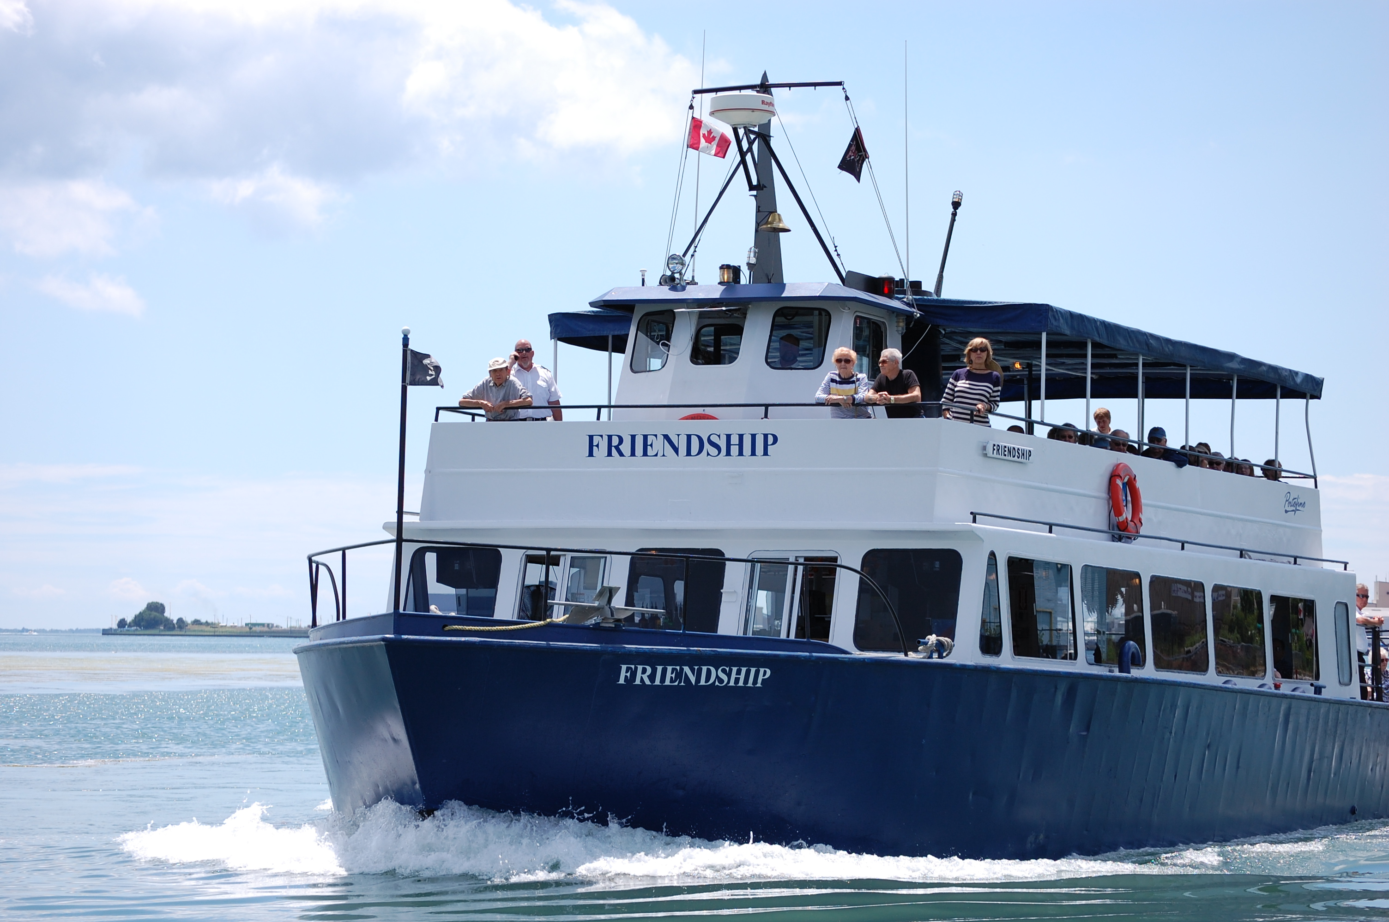

Please Note
For the safety of our guest we reserve the right to inspect any package or bag carried on our ships

All beverages transported carried on our ships must be purchased from Portofino

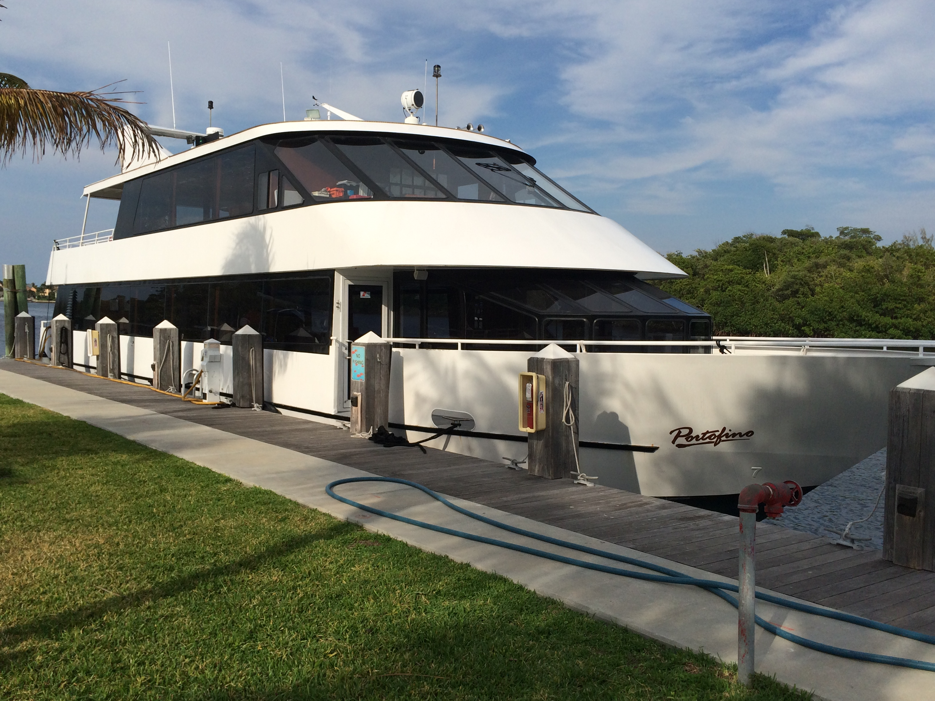

Brunch and Luncheon Menu Times - must be served prior to 2 pm to maintain pricing
Pricing for all banquet events are priced per person plus 6% tax and 21% gratuity
Restaurant and catering events are paid directly following the event with one total payment for all guest
Credit cards and cash only are accepted for final payment. Checks will not be accepted
Cruises are paid in full prior to departure
Three weeks prior to your event you must:
#1 finalize your guest count- your payment is based on this number plus extra guest
#2 finalize your menu
#3 finalize your seating and table set-up -
Please be aware that seasonal items on our menu may change
There is a $100 fee associated with the use of confetti on Portofino property or the use of tape on walls or ceiling surfaces
All banquet deposits are non-refundable
Your guest check average per person before tax and gratuity must equal :
Between the hours of 8 am and 2pm $17
From 2 pm until 12 am $22
River Room minimum for Lunch 50 Guests, $850; Dinner 50 Guests $1100

